## Using Bluetooth APP

**For iOS system:**

1. Open the APP store

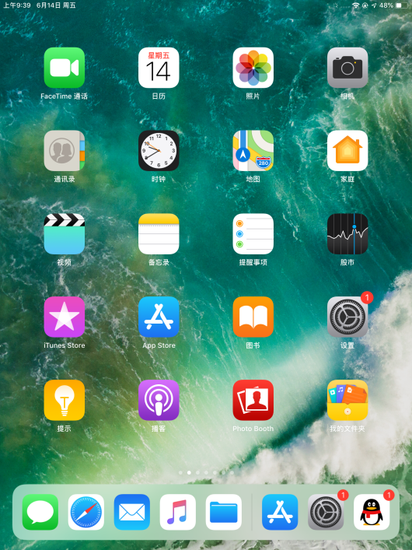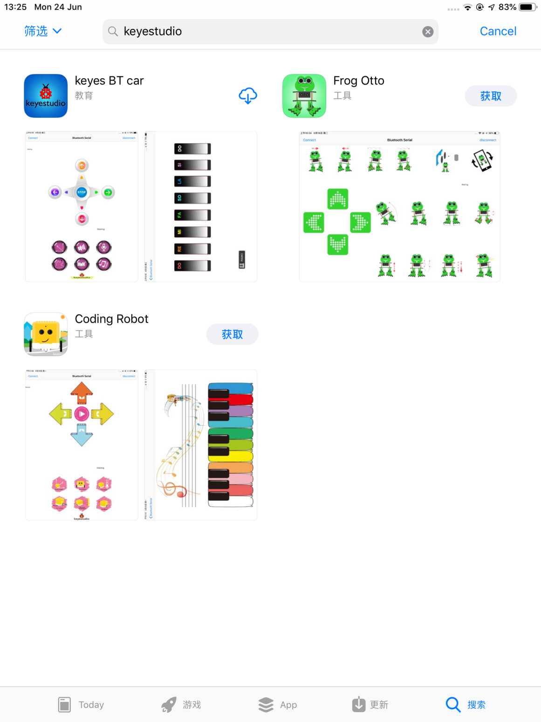

1. Click to search keyestudio, and you will see the keyes BT car.

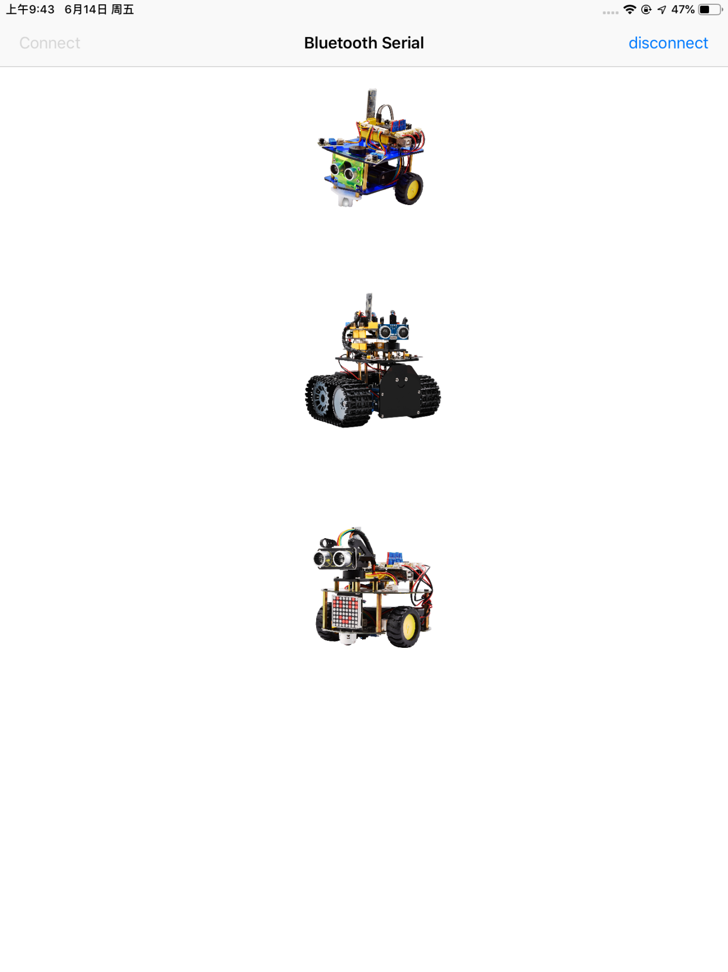

1. Tap to open the keyes BT car
2. To open Bluetooth, click the “Connect” on the upper left corner, searching and connecting Bluetooth.

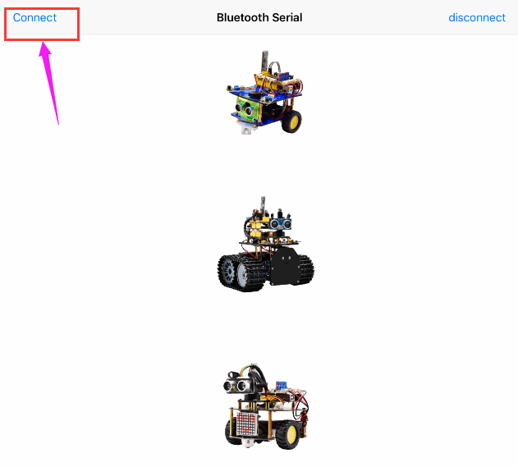

1. Tap the Desktop_Car icon to enter the control interface of desktop car.

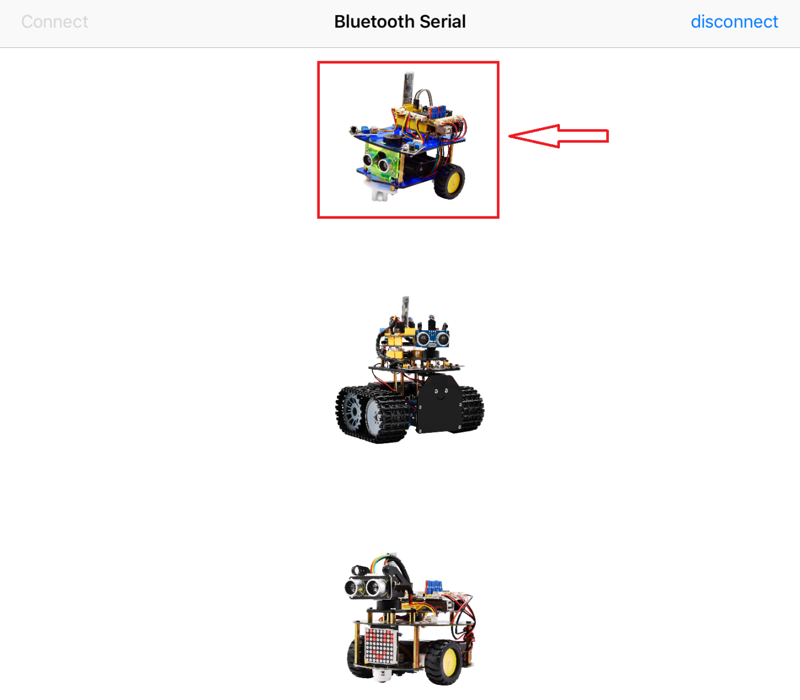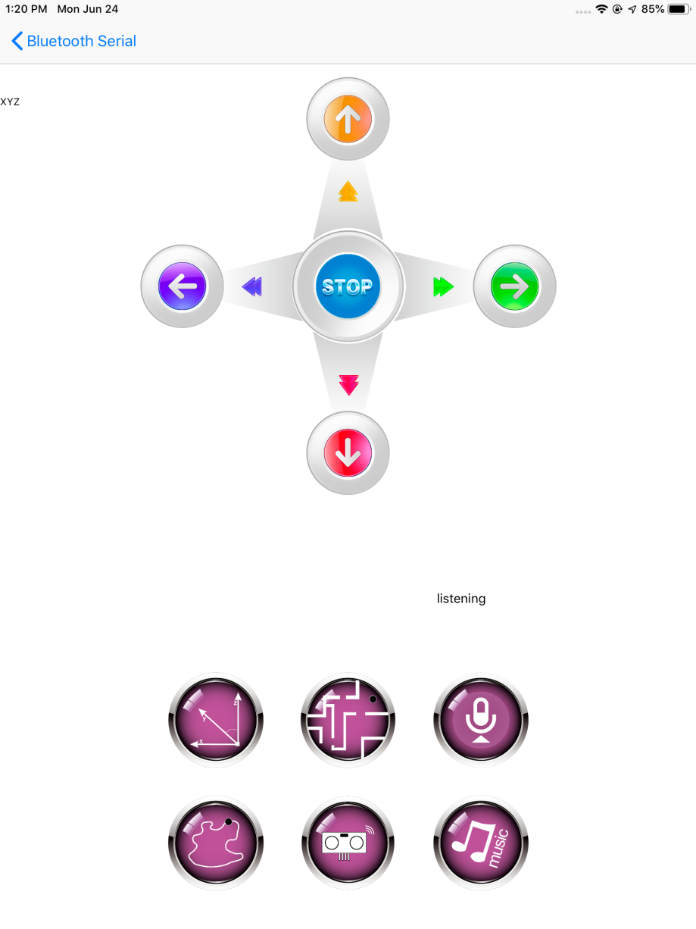

1. Click the music icon to open the music control interface.

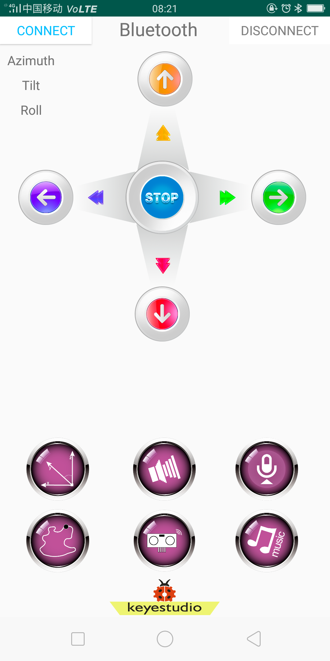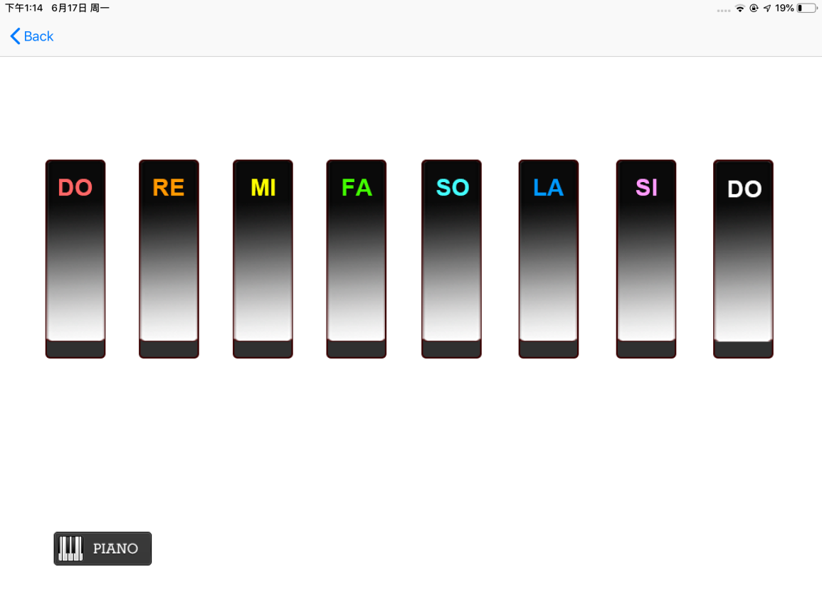

Below we have listed each button on the Bluetooth APP and what each button features.

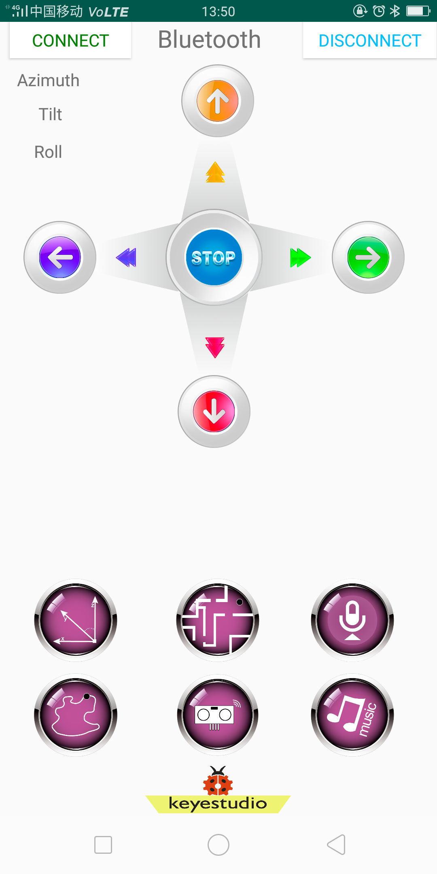

|  |  |  |
| --- | --- | --- |
| **APP Buttons** | **Functions** | |
|  | pair and connect HM-10 Bluetooth module | |
|  | enter Bluetooth control interface | |
|  | disconnect the Bluetooth | |
|  | **Control character** | **Function** |
| Press: F  Release: S | Press the button, robot goes front; release to stop forward |
|  | Press: B  Release: S | Press the button, robot goes back; release to stop backward |
|  | Press: L  Release: S | Press the button, robot turns left; release to stop |
|  | Press: R  Release: S | Press the button, robot turns right; release to stop |
|  | Click to send：W | Click the button, robot always goes straight at the fastest speed |
|  | Click to send：Z | Click the button, robot always goes back at the fastest speed |
|  | Press: Q  Release: S | Pressed, robot rotates to the left |
|  | Press: E  Release: S | Pressed, robot rotates to the right |
|  | Click to send：S | Stop all the functions |
|  | - | Click to start the mobile direction sensing control; click again to exit the function |
|  | Click to send：Y | Start the obstacle avoiding function; click Stop to exit the function |
|  | - | Hold the button,and speak to cellphone:Go, desktop car will move forward; release and hold button again to speak: Stop, car will stop; back, go backward; left, turn left; right, turn right. |
|  | Click to send：X | Start the line tracking function; click Stop to exit |
|  | Click to send：U | Start the ultrasonic follow function; click Stop to exit |
|  | - | Click to enter the music control interface |
| **Click the music iconto enter the music control interface;**  **Music control buttons are as below:** | | |
| **Buttons** | **Control character** | **Function** |
|  | Press: 1  Release: S | Press to play the tone DO; release to stop playing |
|  | Press: 2  Release: S | Press to play the tone RE; release to stop playing |
|  | Press: 3  Release: S | Press to play the tone MI; release to stop playing |
|  | Press: 4  Release: S | Press to play the tone FA; release to stop playing |
|  | Press: 5  Release: S | Press to play the tone SO; release to stop playing |
|  | Press: 6  Release: S | Press to play the tone LA; release to stop playing |
|  | Press: 7  Release: S | Press to play the tone SI; release to stop playing |
|  | Press: 8  Release: S | Press to play the tone DO; release to stop playing |
|  | Press: P  Release: S | Press to play a song Happy Birthday; release to stop playing |
|  | return to the previous step | |